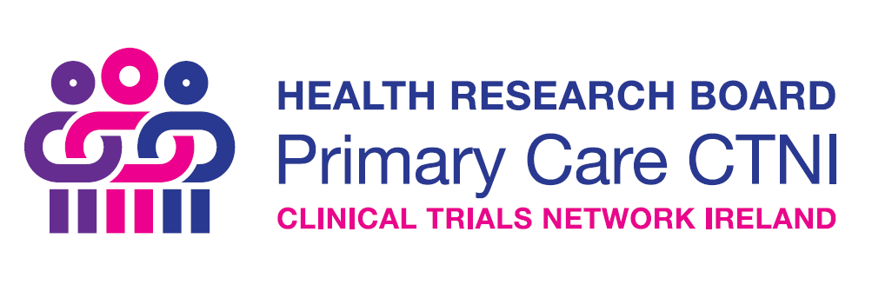
HRB Primary Care CTNI Training Awards

Guidance Notes

Key dates 2019

Call open 1st January 2019

Applicants will receive a response within 4 weeks of application.

Applications must be completed and submitted by email to infor@primarycaretrials.ie with “Training Awards” in the subject line.

GUIDANCE NOTES
Aim of the scheme:
- To increase the knowledge base nationally, with respect to primary care clinical trials and help improve the design, conduct and dissemination of high-quality randomised trials being conducted in Ireland
This scheme creates an opportunity for
- Research teams to apply for funding to host primary care clinical trial-related training events in Ireland
- Individuals to receive trial specific training nationally or internationally
Objectives
The specific objectives of the HRB Primary Care CTNI Training Funding Scheme are to:
- Build capacity and knowledge in primary care clinical trial research nationally;
- Create opportunities for strategic national and international collaboration through networking with recognised leaders in these areas;
- Position Ireland as a leader in primary care clinical trials.
Scope
This scheme will help fund (or part-fund) any training event format, as long as the topic is relevant to primary care clinical trials such as:
- Workshops / seminars
- Summer / Winter schools
- Conferences
- Primary care trial methodology
Subject to capacity and interest, these events can be made available to a wider audience nationally, using the core network organisational supports; such as online registration management, online hosting and online promotion of activities.
It will also fund individuals to attend relevant primary care trial training nationally or internationally.
Funding available
- Up to €3,000 per event to cover costs associated with organising and delivering the event, including travel of international speakers to Ireland.
- Up to €2,000 per person to attend trial-specific training conferences nationally and internationally.
The scheme will not fund
- Current HRB-funded researchers who hold a budget line in an existing grant for the same workshops or conferences as part of dissemination;
- Drinks receptions;
- Development of new educational materials;
- Development of an outreach campaign using media such as television, radio or print;
- Placement/exchange visits for key personnel;
- Promotional tools such as information brochures, plain language summaries, newsletters or policy briefs.
Eligibility
- Any proposed hosted training event must be held on the island of Ireland.
- Training events must be relevant to primary care clinical trials.
- Completed applications must address all assessment criteria identified.

Application and assessment process, and criteria
Applicants should complete and submit the short application form on the following pages, plus a one page CV of lead applicant, to the HRB Primary Care CTNI via email (info@primarycaretrials.ie) for consideration.
Applications will be considered on a rolling basis.
This call is a rolling call and applications are considered throughout the year, subject to annual funding commitment availability. The HRB Primary Care CTNI will commit to a maximum of €10,000 awards annually for two years through this call (i.e. a total of €20,000 over the two years).
Please submit your application at least 8 weeks in advance of your event.
[Note: Research teams wishing to apply for funding in excess of €3,000, should contact the HRB Primary Care CTNI Development Officer by email at nikita.burke@nuigalway.ie to express interest]
All applications submitted will undergo an initial eligibility check and will then be subject to a HRB Primary Care CTNI led review process, based on the criteria outlined below.

Assessment Criteria
Part A (70% of the score)
- Relevance of training to primary care clinical trials;
- Identified a clear gap in training in this area;
Part B (30% of score)
- Appropriate programme and budget
- The budget requested must reflect the scale and nature of the proposed activities
Contact
For further information visit www.primarycaretrials.ie or contact info@primarycaretrials.ie

Application Form

Please complete ALL SECTIONS using font Calibri, size 11pt with single spacing.

Please note it is the responsibility of each applicant to check the word count in each section. Failure to comply within the word counts may result in your application being deemed ineligible without further review.

Completed applications can be submitted by email as a PDF to info@primarycaretrials.ie noting TRAINING AWARD in the subject line.

Details of the Lead Applicant:

Applicant name
Title (Mr., Ms., Dr., Prof. etc.)
Current role
Institution / Organisation
Address
Contact phone number
E-mail

Application to:
- Host an event (please complete all sections), or
- Attend an event (please complete sections A, B, D and G only)
A. Title of proposed training event:

B. Primary care clinical trials subject area:
Please outline how this event relates to training in primary care clinical trials (max 200 words) with particular reference to both the Irish national context, the specific needs of the applicant(s) and expected outcomes.

C. Proposed timeframe for this event:

Please provide a detailed outline of the proposed timeframe from planning, advertising (if needed) to hosting (max 200 words).

D. Details of where this event will be held:

E. Intended target audience of this training (max 200 words):
F. Please describe how the HRB Primary Care CTNI logo will be used before, during and after this event (max 200 words):

G. Budget:

Please provide a detailed breakdown of the proposed spend for this event and the planned use of HRB-CTNI funds

Checklist:

Application Form

One-page CV of Lead Applicant (attach as PDF)

Signature Page (below)

HRB Primary Care CNTI TRAINING AWARDS SCHEME 2018 SIGNATURE PAGE

Applicant

I am submitting this application to the HRB Primary Care CNTI to be considered for funding under the HRB-TMRN TRAINING FUNDING scheme. I confirm that I have read the Guidance Notes for the call and that I will acknowledge the source of funding in any subsequent promotions or publications arising from this work.

Signature: ____________________________________ Date:___________________

Name (Printed): ____________________________________

Head of School / Department / Unit (if not lead applicant)

I have read this application and the relevant Guidance Notes. I confirm that I am aware that the lead applicant is seeking funding to run or attend the proposed event.

Signature: ____________________________________ Date:___________________

Name (Printed): ____________________________________

