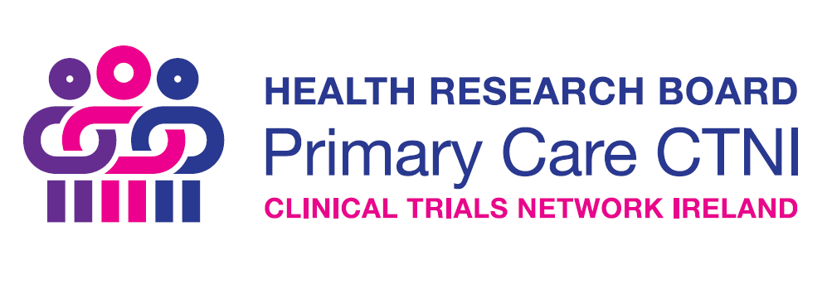
Training Awards 2021-2022
Guidance Notes
Aim
The aim of the HRB Primary Care CTNI Training Awards scheme is to enhance capacity for the conduct of high-quality primary care clinical trials in Ireland
Scope
This scheme will fund (or part-fund) capacity enhancing activities including, but not limited to:
- Attendance at workshops, seminars, conferences, and summer/winter schools, in Ireland or internationally
- Hosting of workshops, seminars, conferences, and summer/winter schools, in Ireland (not internationally)
Eligibility
- Applications must demonstrate clear relevance to primary care trials in Ireland.
Funding available
Applicants may request a maximum of €4,000. Due to budget constrictions, funding awarded must be spent by June 2022.
The scheme will not fund
- Activities already listed as budget line items in any existing grant
- Dissemination activities lacking any training or capacity enhancement element
- Drinks receptions
Administrative support from the HRB Primary Care CTNI
Subject to capacity and interest, funded hosted events can be made available to a wider audience nationally, using HRB Primary Care CTNI organisational supports such as online registration management, online hosting, and online promotion of activities.
Application Process
Applicants should complete the application form and submit a to info@primarycaretrials.ie. Applications open in October 2021 and will be considered on a rolling basis.
Please complete ALL SECTIONS using font Calibri, size 11pt with single spacing. It is the responsibility of each applicant to check the word count in each section. Failure to comply to the word counts may result in your application being deemed ineligible without further review.
Assessment Criteria
Proposal Details (70% of the score)
- Relevance of proposal to primary care clinical trials;
- Identified a clear gap in capacity in this area;
Proposal Budget (30% of score)
- Appropriate programme and budget
- The budget requested must reflect the scale and nature of the proposed activities
Contact
For further information contact info@primarycaretrials.ie

Application Form
Part A: Applicant Details
Please provide the following details for the applicant.
Applicant name
Title (Mr., Ms., Dr., Prof. etc.)
Current role
Institution / Organisation
Address
Contact phone number
E-mail

Part B: Proposal Details
Please outline the proposed capacity enhancement activities, including their relevance to primary care clinical trials in Ireland. Provide a detailed timeframe for all proposed activities. Include a description of how the HRB Primary Care CTNI will be acknowledged in any activities or outputs.
(Max 500 words).

Part C: Proposal Budget
Please provide a detailed breakdown of costs associated with this proposal.
(Max 500 words).

Part D: Applicant CV (1 Page Maximum)

Part E: Required Signatures
Applicant
I am submitting this application to the HRB Primary Care CNTI to be considered for funding under the Training Awards scheme. I confirm that I have read the Guidance Notes for the call and that I will acknowledge the source of funding in any subsequent promotions or publications arising from this work.

Signature: ____________________________________ Date:___________________

Name (Printed): ____________________________________

Head of School / Department / Unit (if not lead applicant)

I have read this application and the relevant Guidance Notes. I confirm that I am aware that the lead applicant is seeking funding to run or attend the proposed event.

Signature: ____________________________________ Date:___________________

Name (Printed): ____________________________________

