Primary Care Research Seed Funding Award

Guidance and Application Form (v1.0)

Purpose of the Award 2
Assessment Criteria 3
Budget and Allowable Costs 4
Lead Applicant & Co-Lead Applicant Eligibility 5
Lead Applicant Eligibility 5
Co-Lead Applicant Eligibility 5
General Instructions 6
Section 1: Lead and Co-Lead Applicant Details 7
Lead Applicant Details 7
Co-Lead Applicant Details (if applicable) 7
Section 2: Study Details 8
Section 3: Expertise in Primary Care Research 9
Section 4: Proposed Study 10
Section 5: Patient and Public Involvement 11
Section 6: Pathway to Future Funding 11
Section 7: Budget 12
Section 8: Signatures 13

Purpose of the Award
The Primary Care Research Seed Funding Award is intended to contribute to the pipeline of clinical trials in Irish Primary Care. It will fund projects up to a value of €10,000 (plus overheads at 25%, or €2,500), which have the potential to be highly impactful and successful in leveraging larger scale research funding in the future. The Award will focus on the current MRC framework for the development and evaluation of complex interventions [1]. See Figure 1 below.

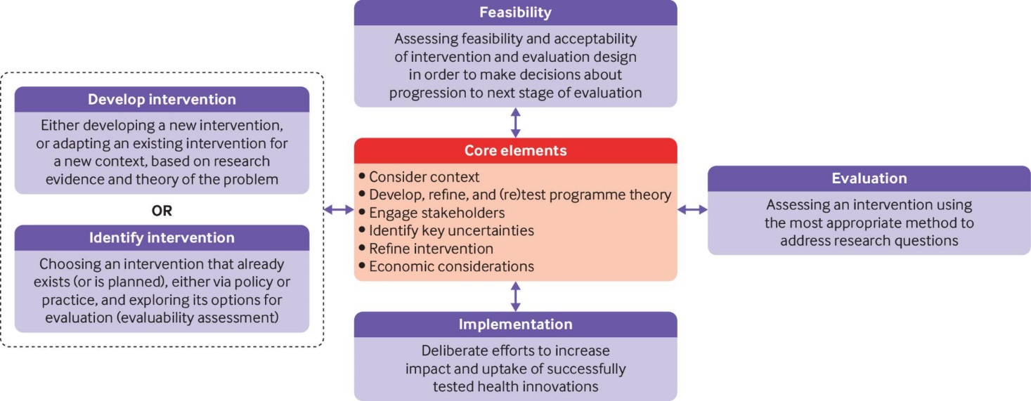
Figure 1. MRC framework for developing and evaluating complex interventions. [1]
Proposed projects may aim to identify or develop an intervention, detailing how the core elements of the MRC framework will be considered. Proposals should identify a pathway to the future acquisition of funding to assess feasibility of the intervention, and (in the longer term) evaluation and implementation of the intervention. Specific funding sources should be identified.

Projects may also aim to redevelop or refine an intervention which has already been the subject of a feasibility study. These projects should aim to address any identified issues with feasibility, with reference to the core elements of the MRC framework. In these cases, the proposal should clearly outline why further feasibility or piloting is required, and identify a pathway to the future acquisition of funding to evaluate the intervention, and (in the longer term) implement the intervention. Specific funding sources should be identified.

[1] Skivington K, Matthews L, Simpson S A, Craig P, Baird J, Blazeby J M et al. A new framework for developing and evaluating complex interventions: update of Medical Research Council guidance BMJ 2021; 374 :n2061 doi:10.1136/bmj.n2061

Assessment Criteria
Reviewers will assess each applicant’s submission and CV, and score based on the following criteria and weightings:

Expertise in Primary Care Research  Does the Lead Applicant (and Co-Lead Applicant, where applicable) have sufficient experience and expertise in primary care research, and access to adequate support? (Application Section 3) | 20%
Proposed Study  Has the applicant proposed a potentially impactful study, with an appropriate methodology? (Application Section 4) | 40%
Patient and Public Involvement  Are the plans for patient and public involvement reflective of best practice? (Application Section 5) | 20%
Pathway to Future Funding  Has the applicant justified how success in the current application will create a pathway to securing a substantial funding award in the future? (Application Section 6) | 20%

Budget and Allowable Costs
This Award will fund projects to a maximum of €10,000 (plus overheads at 25% or €2,500). Allowable costs that can be included are detailed here.

Funds are administered through the approved HRB Host Institutions only: https://www.hrb.ie/funding/funding-schemes/before-you-apply/all-grant-policies/approval-of-host-institutions/

Salary (salary, PRSI, pension contribution)
Applicants may use some or all of the budget to employ research staff. Applicants should use the IUA website for the most up-to-date recommended salary scales for academic researchers (http://www.iua.ie/research-innovation/researcher-salary-scales/). Please note employee pension contribution of 5% has already been incorporated into the IUA gross salary figure. Please state the pay scale used and the level and point on the scale. This should be justified accordingly.

The Primary Care CTNI does not provide funding for the salary or benefits of full-time academic staff within research institutions who are already receiving salary or benefits. The Primary Care CTNI does not provide a salary or buy-out time for collaborators. Employer’s contributions to PRSI and/or national insurance should be at the appropriate rates.

Pension provision up to a maximum of 20% of gross salary will be paid to the host institution to enable compliance with the Employment Control Framework (an additional 5% employee contribution are part of the salary). The level of employer contribution should be in accordance with the model adopted by the host institution.

Running Costs
For all costs required to carry out the activities (e.g. software, design costs etc). Funding for small items of equipment can be included in this section. Standalone computers will not be funded. All costs must be inclusive of VAT, where applicable.

Dissemination
This covers costs associated with article processing fees, seminar/conference attendance (provide details of name and location, where possible), and any other means of communicating outcomes or engaging with stakeholders.

Overhead Contribution
In accordance with the HRB Policy on Overhead Usage, the Primary Care CTNI will contribute to the indirect costs of the research through an overhead payment of 25% of Total Direct Modified Costs. The overhead contribution includes the following items: recruitment costs, office space, and software.

Lead Applicant & Co-Lead Applicant Eligibility

Lead Applicant Eligibility
The Lead Applicant will serve as the point of contact for the Primary Care CTNI during the review process, and on the award if successful. She/he will have primary fiduciary responsibility and accountability for carrying out the research within the funding limits awarded, and in accordance with the terms and conditions of the award.

The Lead Applicant must have the expertise, competencies, and experience to successfully deliver the proposed study. They must justify within the application that they have adequate support in research design, statistics, health economics, and other areas of importance to primary care research.

A Lead Applicant must fulfil one of the following criteria:
- Hold a post (permanent or contract that covers the duration of the award) in a HRB-recognised Host Institution as an independent investigator. For clinicians, an adjunct position in a HRB-recognised Host Institution is acceptable.
or
- Be a contract researcher recognised by the Host Institution as an independent investigator who will have a dedicated office and research space for the duration of award, for which he/she will be fully responsible.

Co-Lead Applicant Eligibility
Where a healthcare practitioner wishes to lead an application but does not meet either criterion 1 or 2 above for a Lead Applicant, they may be designated as a Co-Lead Applicant.

A Co-Lead Applicant must fulfil both of the following criteria:
- Be a practising healthcare practitioner in the Republic of Ireland or Northern Ireland.
and
- Have sufficient expertise, competencies, and experience to meaningfully contribute to the success of the proposed study.

General Instructions
- Complete all sections using font Calibri, size 11pt with 1.5 line spacing.

- Failure to comply with the word count for each section may result in the application being rejected without assessment.

- Completed applications and an applicant CV (max 2 pages) must be submitted by email as a single PDF to murphyp@universityofgalway.ie, noting “Primary Care Research Seed Funding” in the subject line.

- The deadline for receipt of completed applications is 13:00 on Monday May 15th 2023. Late applications will not be accepted.

- Please note that a call FAQ will be maintained at: https://primarycaretrials.ie/researchers/

Section 1: Lead and Co-Lead Applicant Details

Lead Applicant Details

Forename(s)
Surname
Title (Mr, Ms, Dr, Prof, etc.)
Current role
Institution / Organisation
Office address
Contact phone number
E-mail
Contract end date* (if applicable)
*The duration of the proposed study cannot extend beyond the end of an applicant’s contract.

Co-Lead Applicant Details (if applicable)
Forename(s)
Surname
Title (Mr, Ms, Dr, Prof, etc.))
Current role
Institution / Organisation
Office address
Contact phone number
E-mail
Contract end date* (if applicable)

Section 2: Study Details
Project Title
Proposed Host Institution¹
Start Date (dd/mm/yyyy)
Duration (in months)²
¹Funds are administered through the approved HRB Host Institutions only. ²Maximum duration is 12 months

Study Abstract
This should be a succinct summary of the proposed study. The aims of the study should be conveyed with clarity. The objectives of the study and what the work is expected to establish should be described. Ideally it provides a clear synopsis of the proposal and should set the proposal in context. Give specific reference to the MRC framework for the development and evaluation of complex interventions.
(Max 500 Words)

Plain English Summary
Please provide a Plain English Summary of the abstract above. This summary should be clear, easy to understand, and easily accessible to a non-medical, non-research audience. The Plain English Summary may be used when providing information to the public about this scheme, and may be published on primarycaretrials.ie
(Max 500 Words)

Section 3: Expertise in Primary Care Research
Describe how the Lead Applicant has the expertise, competencies, and experience to successfully deliver this particular study. Justify that the applicant has adequate support in research design, statistics, health economics, and other areas of importance to primary care research.
(Max 300 Words)

If applicable, describe the expertise, competencies, and experience of the Co-Lead Applicant, and how those are relevant to the successful delivery of this particular study.
(Max 300 Words)

Section 4: Proposed Study
4.1: Describe the background to the proposed study. Detail the size and nature of the issue to be addressed.
(Max 500 Words)

4.2: Summarise the proposed research plan, specifying the methods that will be used to achieve the aims and objectives outlined in the abstract. Give specific reference to the MRC framework for the development and evaluation of complex interventions.
(Max 500 Words)

4.3 Insert a Gantt chart image showing the estimated timelines, milestones (if applicable), and deliverables for your proposed project.

[INSERT GANTT CHART HERE]

4.4 Please list sources cited in this section.
(Maximum 10 sources).

Section 5: Patient and Public Involvement
Describe any plans for patient and public involvement (PPI) in the proposed study.
(Max 300 Words)

Section 6: Pathway to Future Funding
Provide a description of how success in the current application will create a pathway to securing a substantial funding award in the future. Give specific reference to the MRC framework for the development and evaluation of complex interventions.
(Max 300 Words)

Section 7: Budget
For each item below, please provide a justified budget relative to the scale and size of the research study proposed. The maximum allowed budget is €10,000, exclusive of overheads. Overheads will be paid at 25% of direct project costs.

Note: costs relating to student stipends/fees and equipment are not eligible for inclusion.

Item | € | Brief justification
Salary Costs
Salary PRSI
Salary Pension Contribution
Running Costs
Dissemination
Total (excl. overhead)
Overhead (25% total direct project costs)
Total (direct project costs inc. overhead)

Section 8: Signatures

Person authorised to endorse research grant applications for the Host Institution (Research Office or Dean of Research). E-signatures are acceptable.
I have read this application and the relevant Guidance Notes. I confirm that all staffing/budget issues have been discussed with the applicant, and the host institution is willing to accept and administer the award if successful. I confirm that published standards of good research practice, including a formal written procedure for the investigation of scientific fraud, are in place in this institution.

Signature: ____________________________________ Date:___________________

Name (Printed): ___________________________________

Position/Institution: ___________________________________

Applicant

I am submitting this application to the Primary Care CTNI to be considered for funding under the Primary Care Research Seed Funding scheme. I confirm that I have read the Guidance Notes for the scheme and will acknowledge the source of funding in any subsequent publications arising from this work.

Signature: ____________________________________ Date:___________________

Name (Printed): ____________________________________

